***Hands on 1***  
Create a Spring Web Project using Maven

Follow steps below to create a project:  
**1.** Go to **https://start.spring.io/**  
2. Changed Group as “**com.cognizant**”  
3. Changed Artifact Id as “**spring-learn**”  
4. Selected Spring Boot **DevTools** and **Spring Web**  
5. Created and downloaded the project as zip  
6. Extracted the zip in root folder to Eclipse Workspace  
7. Build the project using ‘mvn clean package -  
Dhttp.proxyHost=proxy.cognizant.com -Dhttp.proxyPort=6050 -  
Dhttps.proxyHost=proxy.cognizant.com -Dhttps.proxyPort=6050 -  
Dhttp.proxyUser=123456’ command in command line  
8. Import the project in Eclipse "File > Import > Maven > Existing Maven  
Projects > Click Browse and select extracted folder > Finish"  
9. Include logs to verify if main() method of SpringLearnApplication.  
10. Run the SpringLearnApplication class.

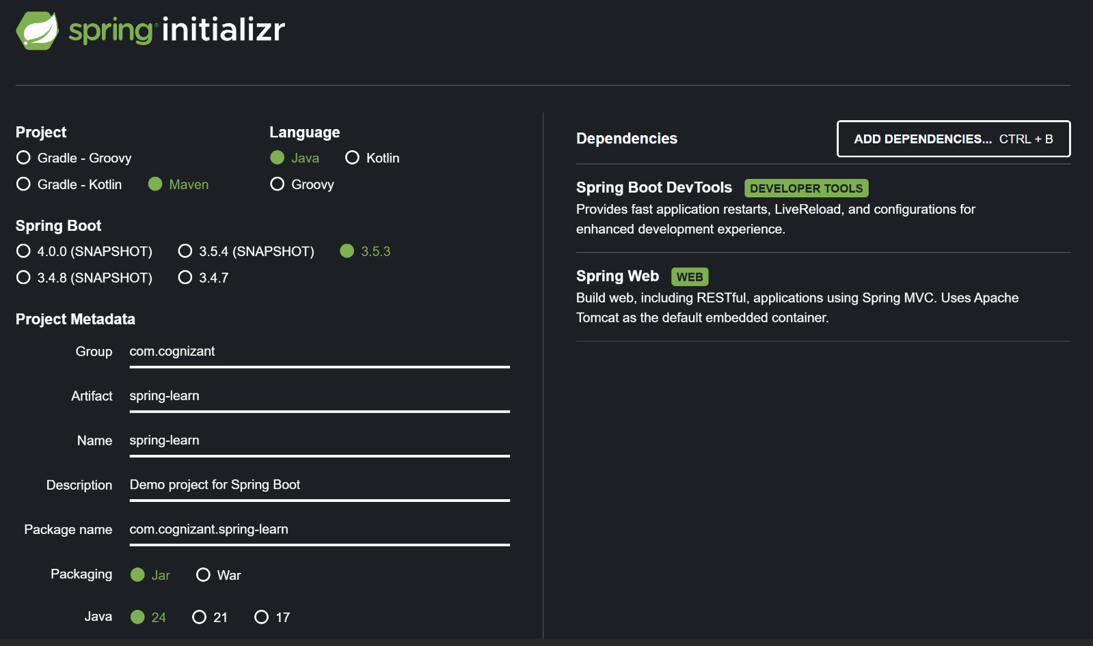

Output of the maven project : Screenshots are provided below .

Built the project using mvn clean package :

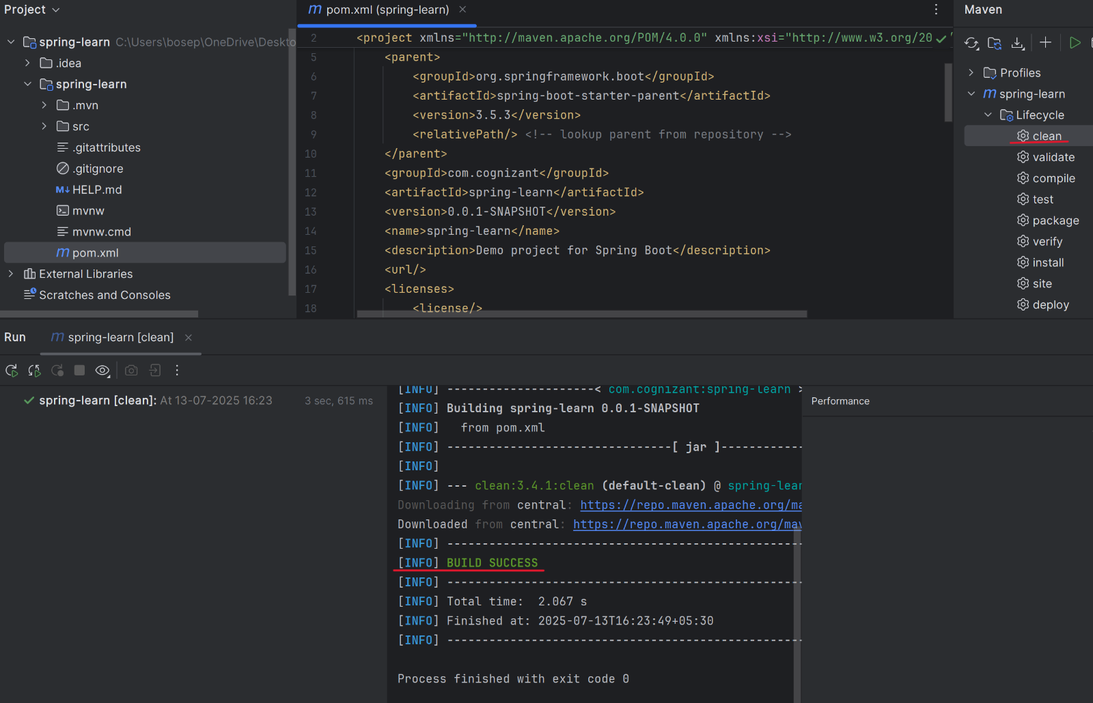

Runned the **SpringLearnApplication.java** and included logs to verify main()



